Muhammad Abdullah

SE(6A) | 19F-0916

Web Engineering Lab

Lab 15: Deep Into react

**TASK 1**

**App.js Code for REACT App**

import logo from './National_University_of_Computer_and_Emerging_Sciences_logo-removebg-preview.png';

import './App.css';

function App() {

  return (

    <div className="App">

      <header className="App-header">

        <img src={logo} className="App-logo" alt="logo" />

        <p>

          Roll: 19F-0916 and Name: M Abdullah.

        </p>

      </header>

    </div>

  );

}

export default App;

Image Animation Time Reduced to 2 Seconds

Please Use Code to View the Moving/Animating Icon for FAST NUCES Icon

**TASK 2**

**React in HTML Page:**

<!DOCTYPE html>

<html>

  <head>

    <script src="https://unpkg.com/react@18/umd/react.development.js" crossorigin></script>

    <script src="https://unpkg.com/react-dom@18/umd/react-dom.development.js" crossorigin></script>

    <script src="https://unpkg.com/@babel/standalone/babel.min.js"></script>

    <link rel="stylesheet" href="task2.css">

  </head>

  <body>

    <div id="mydiv"></div>

    <script type="text/babel">

      function App() {

        function Table() {

        var i = 1;

        var ans = "";

        var table = +document.getElementById("firstNumber").value;

        var result = document.getElementById("result");

        for (i = 1; i <= 10; i++) {

        ans += ("<br>" + table + " x " + i + " = "  + (table * i) );

        }

        ans += "";

        result.innerHTML = ans;

    }

    return (

    <div class="container">

      <br></br>

      <div class="format">

        <div class="card-body">

          <h2 >React Table Calculation</h2>

          <form id="final">

            <div >

              <label>Enter the Number to Calculate : </label>

              <input className='field' type="text" id="firstNumber" />

            </div>

            <button className='btn' type="button" onClick={Table} id="submit">Calculate Results</button>

            <p id="result">

            </p>

          </form>

        </div>

      </div>

    </div>

  );

}

      ReactDOM.render(<App />, document.getElementById('mydiv'))

    </script>

  </body>

</html>

**CSS File for the Task 2**

.format{

    font-size: 30px;

    text-align: center;

    margin-top: 1%;

    margin-left: 5%;

  }

  .btn{

    font-size: 30px;

    text-align: center;

    margin-top: 1%;

  }

  .field{

    font-size: 20px;

    text-align: center;

    margin-top: 1%;

  }

**Running Code Screenshot**

**TASK 3**

**React in HTML Page:**

<!DOCTYPE html>

<html>

  <head>

    <script src="https://unpkg.com/react@18/umd/react.development.js" crossorigin></script>

    <script src="https://unpkg.com/react-dom@18/umd/react-dom.development.js" crossorigin></script>

    <script src="https://unpkg.com/@babel/standalone/babel.min.js"></script>

    <link rel="stylesheet" href="task2.css">

  </head>

  <body>

    <div id="mydiv"></div>

    <script type="text/babel">

      function App() {

  return (

    <div className = "form-box">

        <h5 className = "form-step"> REACT FORM </h5>

        <form>

            <div className = "field1">

            <input placeholder="Name"/>

            <input placeholder="UserName"/>

            <input placeholder="Password"/>

            <input placeholder="Confirm Password"/>

            </div>

            <button type = "submit" id= "submitBtn" className = "sbtBtn"> Submit Details</button>

        </form>

    </div>

  );

}

      ReactDOM.render(<App />, document.getElementById('mydiv'))

    </script>

  </body>

</html>

**CSS File for the Task 3**

*{

    box-sizing: border-box;

    margin: 0;

    padding: 0;

    border: 3px solid rgb(15, 14, 14);

  }

  .form-box{

    min-width: 100%;

    height: 100vh;

    background-color: rgb(110, 77, 208);

    margin: 0vw;

    padding: 5vw ;

    position:relative;

    text-align: center;

  }

  .form-box h5{

    font-size: 35px ;

    text-align: center;

    color: #fdfdfd;

    margin: 0 0 .5vh 0;

  }

  .form-box label{

    display: block;

    text-align: center;

    font-size: 20px;

    margin: 0 0 2vh 0;

  }

  .form-box input{

    display: block;

    width: 100%;

    padding: .5rem .8rem .5rem .8rem;

    margin: .9vw 0 ;

    border:0;

    border-radius: 5px;

    text-align: center;

    font-size: 25px;

  }

  .sbtBtn{

    display: inline-block;

    width: 50%;

    height: 3rem;

    text-align: center;

    color: rgb(2, 1, 1);

    border: 3px solid rgb(15, 14, 14);

    bottom: 0;

    cursor: pointer;

    font-size: 30px;

    border-radius: 20px 20px 20px 20px;

  }

**Screenshot of Running Code**

**TASK 4**

**React Code for Showing Lists:**

import './App.css';

function App() {

  return (

    <div >

      <h1>UnOrdered List</h1>

      <p>We Have Books On A Variety Of Languages</p>

      <ul>

        <li>Oracle</li>

        <li>Java</li>

        <li>HTML</li>

        <li>CSS</li>

      </ul>

      <br></br>

      <h1>Ordered List</h1>

      <p>Follow These Steps To Install Java</p>

      <ol>

        <li>Download The Software.</li>

        <li>Extract to a folder.</li>

        <li>Double Click the Executable File To Run</li>

      </ol>

    </div>

  );

}

export default App;

**Screenshot of Running Code**

**TASK 5**

**React Code for Showing Lists:**

import './App.css';

function App() {

  return (

    <div >

      <h1 >UnOrdered List</h1>

      <p>We Have Books On A Variety Of Languages</p>

      <ul className = "UnorderedList">

        <li className="ListItems">Oracle</li>

        <li className="ListItems">Java</li>

        <li className="ListItems">HTML</li>

        <li className="ListItems">CSS</li>

      </ul>

      <br></br>

      <h1 >Ordered List</h1>

      <p>Follow These Steps To Install Java</p>

      <ol className = "OrderedList">

        <li className="ListItems">Download The Software.</li>

        <li className="ListItems">Extract to a folder.</li>

        <li className="ListItems">Double Click the Executable File To Run</li>

      </ol>

    </div>

  );

}

export default App;

**CSS File for the Task 5**

.OrderedList{

color: red;

}

.UnorderedList{

color: blue;

}

.ListItems{

font-size: 36px;

font-family: Verdana, Geneva, Tahoma, sans-serif;

}

**Output of Running Code**

**TASK 6**

**React Code for Showing Lists with Functional Component:**

import './App.css';

function App() {

  function OrderedList(){

    return(

      <div>

        <h1 >Ordered List</h1>

        <p>Follow These Steps To Install Java</p>

        <ol className = "OrderedList">

        <li className="ListItems">Download The Software.</li>

        <li className="ListItems">Extract to a folder.</li>

        <li className="ListItems">Double Click the Executable File To Run</li>

      </ol>

      </div>

    )

  }

  function UnOrderedList(){

    return(

      <div>

       <h1 >UnOrdered List</h1>

      <p>We Have Books On A Variety Of Languages</p>

      <ul className = "UnorderedList">

        <li className="ListItems">Oracle</li>

        <li className="ListItems">Java</li>

        <li className="ListItems">HTML</li>

        <li className="ListItems">CSS</li>

      </ul>

      </div>

    )

  }

  return (

    <div >

      <UnOrderedList/>

      <OrderedList/>

    </div>

  );

}

export default App;

**React Code for Showing Lists with Class Component:**

import './App.css';

import React from 'react'

function App() {

  class OrderedList extends React.Component{

    render(){

      return(

        <div>

          <h1 >Ordered List</h1>

          <p>Follow These Steps To Install Java</p>

          <ol className = "OrderedList">

          <li className="ListItems">Download The Software.</li>

          <li className="ListItems">Extract to a folder.</li>

          <li className="ListItems">Double Click the Executable File To Run</li>

        </ol>

        </div>

      )

    }

  }

  class UnOrderedList extends React.Component{

    render(){

    return(

      <div>

       <h1 >UnOrdered List</h1>

      <p>We Have Books On A Variety Of Languages</p>

      <ul className = "UnorderedList">

        <li className="ListItems">Oracle</li>

        <li className="ListItems">Java</li>

        <li className="ListItems">HTML</li>

        <li className="ListItems">CSS</li>

      </ul>

      </div>

    )

  }

}

  return (

    <div >

      <UnOrderedList/>

      <OrderedList/>

    </div>

  );

}

export default App;

**Running Code Screenshot**

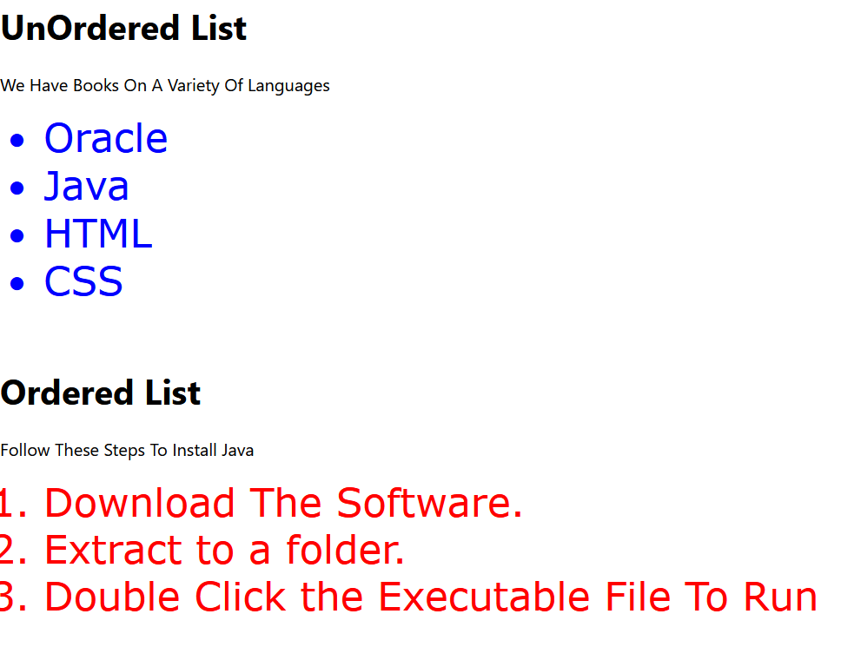

**TASK 7**

**React Code for Capitals of Provinces of Pakistan:**

import './App.css';

import React from 'react'

function App() {

  class Provinces extends React.Component{

    render(){

      return(

        <div>

          <h1 >List of Provinces Are:</h1>

          <ol className = "OrderedList">

          <li className="ListItems">Punjab.</li>

          <li className="ListItems">Sindh.</li>

          <li className="ListItems">Balochistan</li>

          <li className="ListItems">KPK</li>

          <li className="ListItems">Gilgit Baltistan</li>

        </ol>

        </div>

      )

    }

  }

  class Capitals extends React.Component{

    render(){

    return(

      <div>

      <h1 >List of Capital of Provinces Are:</h1>

      <ul className = "UnorderedList">

      <li className="ListItems">Lahore.</li>

          <li className="ListItems">Karachi.</li>

          <li className="ListItems">Quetta</li>

          <li className="ListItems">Peshawar</li>

          <li className="ListItems">Gilgit</li>

      </ul>

      </div>

    )

  }

}

class FinalComponent extends React.Component{

  render(){

  return(

    <div>

    <Provinces/>

    <Capitals/>

    </div>

  )

}

}

  return (

    <div >

      <FinalComponent/>

    </div>

  );

}

export default App;

**CSS Code**

.OrderedList{

color: red;

}

.UnorderedList{

color: blue;

}

.ListItems{

font-size: 36px;

font-family: Verdana, Geneva, Tahoma, sans-serif;

}

**Running Code Screenshot**

**TASK 8**

**React Code for Capitals of Countries:**

import './App.css';

import React from 'react'

function App() {

  function CapitalOfCountries(props){

      return(

        <div>

          <h3 >My Name Is { props.provinces.captial } And I Am The Captial of {props.provinces.name}</h3>

        </div>

      )

    }

  function Capitals(){

      const Pakistan = { name: "Pakistan", captial: "Islamabad" };

      const India = { name: "India", captial: "Delhi" };

      const Turkey = { name: "Turkey", captial: "Ankara" };

    return(

      <div>

        <h1>Capital of Countires Are:</h1>

        <CapitalOfCountries provinces={ Pakistan } />

        <CapitalOfCountries provinces={ India } />

        <CapitalOfCountries provinces={ Turkey } />

      </div>

    )

  }

  return (

    <div >

      <Capitals/>

    </div>

  );

}

export default App;

**Running Code Screenshot**

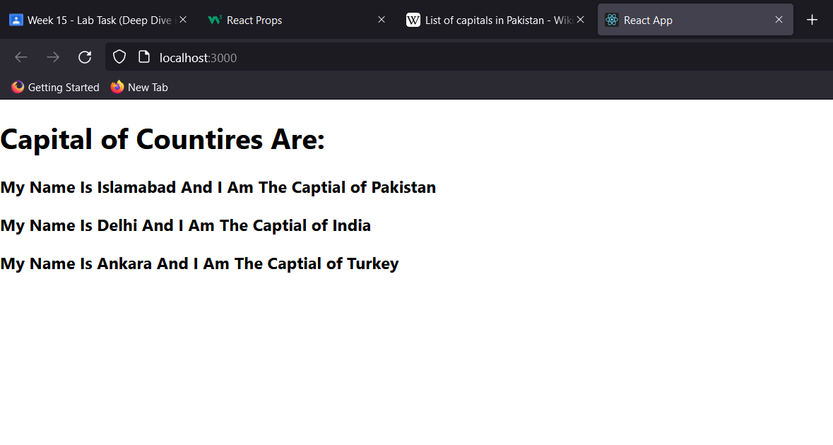

**TASK 9**

**React Code for Showing Lists:**

import './App.css';

function App() {

  return (

    <>

    <div >

      <h1 style={{color: "blue"}}>UnOrdered List</h1>

      <p>We Have Books On A Variety Of Languages</p>

      <ul style={{fontSize: "36px",

          fontFamily: "Verdana, Geneva, Tahoma, sans-serif"}}>

        <li style={{color: "pink"}}>Oracle</li>

        <li style={{color: "green"}}>Java</li>

        <li style={{color: "yellow"}}>HTML</li>

        <li style={{color: "orange"}}>CSS</li>

      </ul>

      <br></br>

      <h1 style={{color: "red"}}>Ordered List</h1>

      <p>Follow These Steps To Install Java</p>

      <ol style={{fontSize: "36px",

          fontFamily: "Verdana, Geneva, Tahoma, sans-serif"}}>

        <li style={{color: "cyan"}}>Download The Software.</li>

        <li style={{color: "black"}}>Extract to a folder.</li>

        <li style={{color: "grey"}}>Double Click the Executable File To Run</li>

      </ol>

    </div>

    </>

  );

}

export default App;

**Running Code Screenshot**

**TASK 10**

**React Code for Tables with Hooks and States**

import './App.css';

import React, { useState } from "react";

function App() {

  const [table, setTable] = useState(0);

  function calculateTable(props) {

    setTable(props)

    var i = 1;

    var ans = "";

    var result = document.getElementById("result");

    for (i = 1; i <= 10; i++) {

      ans += ("<br>" + table + " x " + i + " = " + (table * i));

    }

    ans += "";

    result.innerHTML = ans;

  }

  return (

    <div class="container">

      <br></br>

      <div class="format">

        <div class="card-body">

          <h2 >React Table Calculation Using Hooks</h2>

          <button className='btn' type="button" onClick={() => calculateTable(2)} id="submit">Calculate Table for 2</button>

          <button className='btn' type="button" onClick={() => calculateTable(3)} id="submit">Calculate Table for 3</button>

          <button className='btn' type="button" onClick={() => calculateTable(4)} id="submit">Calculate Table for 4</button>

          <button className='btn' type="button" onClick={() => calculateTable(5)} id="submit">Calculate Table for 5</button>

          <p id="result">

          </p>

        </div>

      </div>

    </div>

  );

}

export default App;

**CSS File Code**

.format{

  font-size: 30px;

  text-align: center;

  margin-top: 1%;

  margin-left: 5%;

}

.btn{

  font-size: 30px;

  text-align: center;

  margin-top: 1%;

  margin-left: 2%;

}

.field{

  font-size: 20px;

  text-align: center;

  margin-top: 1%;

}

**Running Code Screenshot Initial State**

**Running Code Screenshot 2 Table State**

**Running Code Screenshot 3 Table State**

**Running Code Screenshot 4 Table State**

**Running Code Screenshot 5 Table State**

